Methodology & Limitations

For this analysis, we decided to see if there was a correlation between the performance of Toronto’s MLB team - the Toronto Blue Jays – and Toronto Railway Museum (TRM) visitor rates. More specifically, we are looking to see if the final score of Blue Jay’s games (i.e. whether they win or lose) causes a change in number of ticket sales at the TRM. To determine if there are any trends between these two variables, we will look at data over a 3-year time period from 2017 to 2019. Brian Morningstar, External Relations Coordinator at the TRM, provided data regarding daily ticket sales, and further secondary research was performed to gather relevant data about Blue Jay’s baseball games, including: date of game, final result (win/loss), and total attendance of each game.

Potential limitations for this analysis include:

* This analysis is limited to the length of the baseball season, which ranges from late March/early April to the end of September.
* 2017 data is limited to the final 2 months of the baseball season (August and September).
* This analysis does not account for other external factors that could also be the reason for increased/decreased visitor rates (i.e. weather, promotional events).
* It is possible that some baseball games took longer to complete than others (i.e. if the game was tied and went into extra innings). As a result, some games may have extended past the hours of operation for the TRM.

Key Findings

*Note: there were several instances where a baseball game was played but there was no corresponding ticket sales data on that date (possibly due to holidays, closures, etc). To avoid skewing the data by having some ‘zero’ entries, this analysis will only consider dates where both a Blue Jays home game was played and there was at least 1 ticket sold at the TRM.*

Due to limited data regarding TRM ticket sales in 2017, only the final 2 months of the baseball season - August and September – could be analyzed. The Blue Jays played 3 games at the Rogers Centre in August and 9 games in September, for a total of 12 games. A visual representation of monthly ticket sales is shown below:

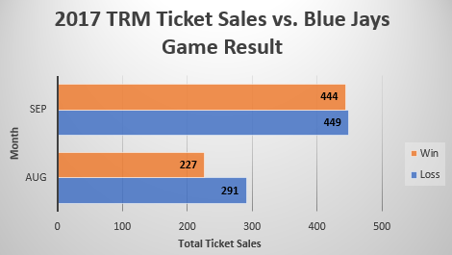

At first glance, it appears that the outcome of the Blue Jays game did not matter, with 740 tickets sold during the games that were lost vs. only 671 sold during the games that were won. Further analysis discovered the following:

* Of those 12 games played at Rogers Centre, the Blue Jays won 5 of them and lost 7.
* The TRM sold 671 tickets during the 5 games that the Blue Jays won, an average of 134 tickets each day.
* The TRM sold 740 tickets during the 7 games that the Blue Jays lost, an average of 106 tickets each day.
* Refer to Exhibit 1 & 2 in Appendix A for a full daily & monthly breakdown of ticket sales.

The TRM sold an average of 28 more tickets on days where the Blue Jays won vs. when they lost. However, this sample size is too small to draw a definitive conclusion from, so we’ll look at additional data from following years to see if the trend continues.

In 2018, enough data was available to be able to analyze a full Blue Jays season worth of games. The Blue Jays played 3 games in March, 6 games in April, 8 games in May, 12 games in June, 13 in July, 12 in August and 5 in September, for a total of 59 games. A visual representation of monthly ticket sales is shown below:

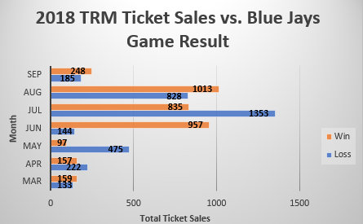

The 2018 data shows slightly different results when compared to the 2017 graph. In 2018, a total of 3,466 tickets were sold on days where the Blue Jays won vs. 3,340 tickets sold on days where the Blue Jays lost. Further analysis revealed the following:

* Of the 59 games played at Rogers Centre, the Blue jays lost 29 of them and won 30.
* The TRM sold 3,466 tickets during the 30 games that the Blue Jays won, an average of 116 tickets each day.
* The TRM sold 3,340 tickets during the 29 games that the Blue Jays lost, an average of 115 tickets each day.
* Refer to Exhibit 3 & 4 in Appendix A for a full daily & monthly breakdown of ticket sales.

When analyzed over a full season, the results are not as promising as they looked in the small sample size analyzed in 2017. On average, TRM sold just 1 more ticket per day when the Blue Jays won vs. when they lost.

In 2019, we also had enough data to analyze a full Blue Jays season worth of games. The Blue Jays played 4 games in March, 8 games in April, 7 games in May, 12 games in June, 13 games in July, 14 games in August, and 10 games in September for a total of 68 games. A visual representation of monthly ticket sales is shown below:

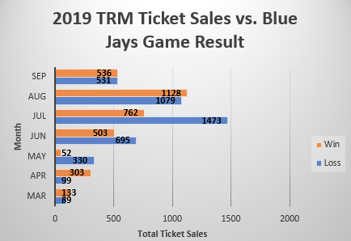

The 2019 data shows a significant difference in tickets sold when the Blue Jays lost vs. when they won. In 2019, there were 4,296 tickets sold on days where the Blue Jays lost vs. 3,417 tickets when the Blue Jays won. Further analysis revealed the following:

* Of the 68 games played at Rogers Centre, the Blue jays lost 38 of them and won 30.
* The TRM sold 3,417 tickets during the 30 games that the Blue Jays won, an average of 114 tickets each day.
* The TRM sold 4,296 tickets during the 38 games that the Blue Jays lost, an average of 113 tickets each day.
* Refer to Exhibit 5 & 6 in Appendix A for a full daily & monthly breakdown of ticket sales.

With another full season analysis, the results are nearly identical to those found in 2018. Just like in the previous year, the TRM sold just 1 more ticket on average each day when the Blue Jays won vs. when the Blue Jays lost.

Before drawing any final conclusions about what we have learned so far, there was one more cross-tabulation we thought was relevant to make. We decided to see if the average number of people attending the Blue Jays games analyzed above was affecting the average number of tickets sold. The following table shows the results:

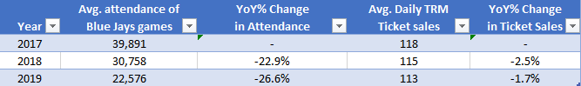

Based on these findings, it appears that the average attendance of a Blue Jays game has a minuscule effect on the average number of tickets sold at the TRM. As the attendance of Blue Jays games has decreased by over 20% in both 2018 and 2019, the average ticket sales at the TRM has decreased just 2.5% and 1.7% in 2018 and 2019, respectively.

Conclusion

It is safe to conclude that the outcome of a Blue Jays game does not significantly impact the number of tickets sold at the TRM. While the small sample size in 2017 initially made it appear that the Blue Jays winning was a significant driver in ticket sales, additional analysis proved this not to be true. Once two full seasons of games were added to the analysis, it was discovered that the TRM sold on average just 1 more ticket per day when the Blue Jays won vs. when they lost.

An interesting insight that was discovered was the average number of people attending Blue Jays games has an insignificant effect on the average number of tickets sold at the TRM. In 2018 and 2019, the year over year % change in average Blue Jays attendance was -22.9% and -26.6%, respectively. Over the same time period, the year over year % change in average TRM ticket sales was -2.5% and -1.7%.

To further prove this point, the average Blue Jays game attendance in 2019 was 17,315 less than in 2017, or 43.4% less. At the same time, the average daily tickets sold at TRM in 2019 was 5 less than in 2017, or 4% less. Ticket sales were not impacted significantly despite a large drop in attendance at Blue Jays games. This provides some valuable information regarding the TRM’s target customer – the type of people that are interested in Blue Jays games do not share the same interest in the TRM. Refer to Exhibit 7, 8 and 9 in Appendix A for a full list of the data.

Recommendation

Now that we have determined most people attending Blue Jays games do not share an interest in the TRM, I would recommend that the TRM not focus any attention with regards to promotional activities towards the people at Blue Jays games. Additionally, any advertising/partnership deals with the Blue Jays (such as “Free ride on the mini-train if the Blue Jays win”) would not be worth the investment, and the resources would likely be better utilized elsewhere. Lastly, when TRM does decide to have promotional activities, they need not wait for the Blue Jays to be playing in town, as the increased number of people in the area is not a significant driver in ticket sales.

References

https://www.espn.com/mlb/team/schedule/_/name/tor/season/2019/seasontype/2/half/2

Exhibit 1 – 2017 Ticket sales by day

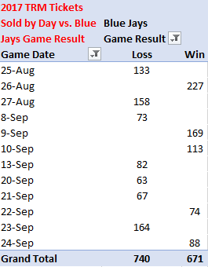

Exhibit 2 – 2017 Ticket sales by month

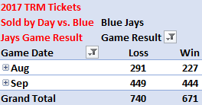

Exhibit 3 – 2018 ticket sales by day



Exhibit 4 – 2018 ticket sales by month

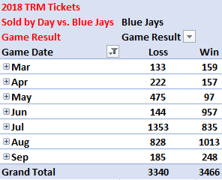

Exhibit 5 – 2019 ticket sales by day



Exhibit 6 – 2019 ticket sales by month

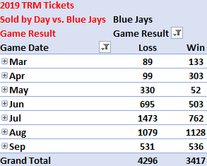

Exhibit 7 – 2017 data



Exhibit 8 – 2018 data



Exhibit 9 – 2019 data

